From the book of Matthew in the Bible
Matthew 5, verses 14-16 (International Children’s Bible)

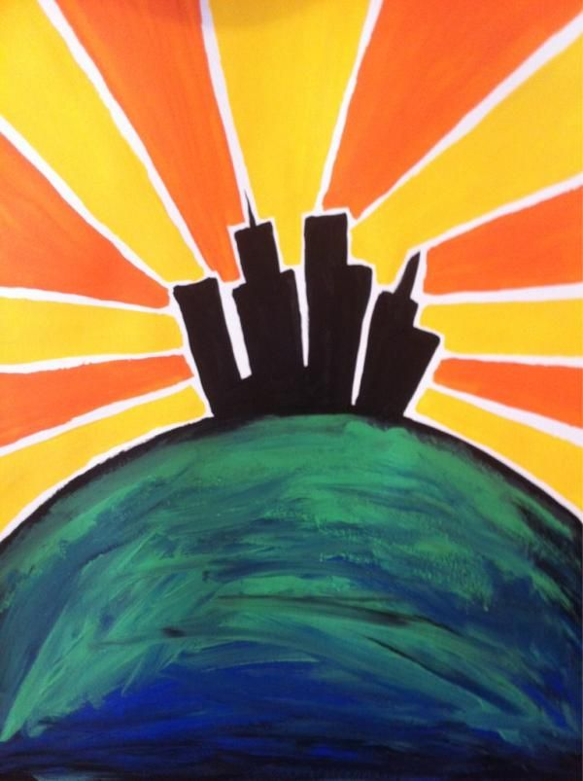

Jesus said:
¹⁴ “You are the light that gives light to the world. A city that is built on a hill cannot be hidden. ¹⁵ And people don’t hide a light under a bowl. They put the light on a lampstand. Then the light shines for all the people in the house. ¹⁶ In the same way, you should be a light for other people. Live so that they will see the good things you do. Live so that they will praise your Father in heaven.

