From the book of Psalms in the Bible
Psalm 119, verses 105-106 (International Children’s Bible)

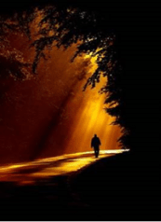

¹⁰⁵ Your word is like a lamp for my feet
and a light for my way.
¹⁰⁶ I will do what I have promised
and obey your fair laws.

